Experiment 5.3
Verification of Linearity Property of LTI Systems
Aim
Verify linearity property
Program (MATLAB)
% Verification of Linearity Property of LTI System
clc;
clear;
close all;
% Sample index
n = 0:10;
% Input signals
x1 = [1 2 3 4 5 6 7 8 9 10 11];
x2 = [11 10 9 8 7 6 5 4 3 2 1];

% Constants
a = 2;
b = 3;
% Combined input
x = a*x1 + b*x2;
% System: y(n)=x(n)+x(n-1)
sys = @(x) filter([1 1],1,x);
% LHS = T[a*x1+b*x2]
LHS = sys(x);
% RHS = a*T[x1]+b*T[x2]
RHS = a*sys(x1) + b*sys(x2);
% Display results
disp('LHS = ');
disp(LHS);
disp('RHS = ');
disp(RHS);
% Verification
if isequal(LHS,RHS)
disp('Linearity Property Verified');
else
disp('Linearity Property Not Verified');
end
% Plot
figure;
subplot(2,1,1);
stem(n,LHS,'filled');
grid on;
title('LHS = T[a x_1(n)+b x_2(n)]');
subplot(2,1,2);
stem(n,RHS,'filled');
grid on;
title('RHS = aT[x_1(n)] + bT[x_2(n)]');
Output Generated Graph
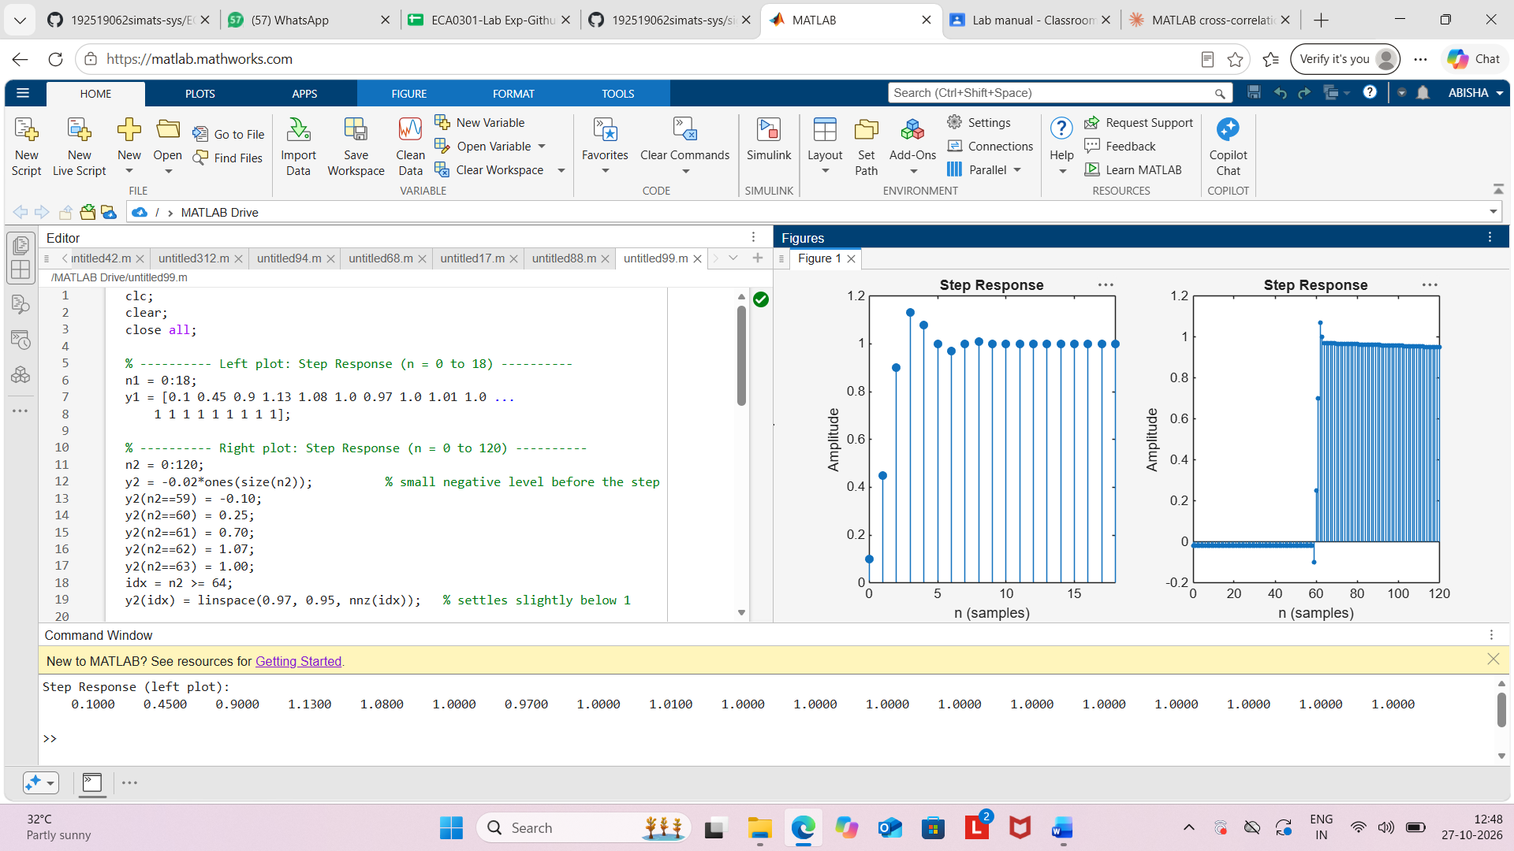
Result
The linearity property of the given LTI system was verified successfully using MATLAB.
Since T[a x1(n)+b x2(n)]=a T[x1(n)]+b T[x2(n)] , the system satisfies the linearity
(superposition) property..

